WVFLTA Connections – Workshop, Series 3 - Winter/Spring 2025
THEME: Using AI Technology to Facilitate Lesson
Development and Enhance Language Learning

“GenAI won’t replace teachers.
It will replace teachers who don’t work with GenAI.”
Sarah Dutton, The Language Educator-Summer 2024
(an AI suggested title for her article)

DATES - SESSIONS - PRESENTERS:
Wednesday, March 12 ▪ 7-8 PM  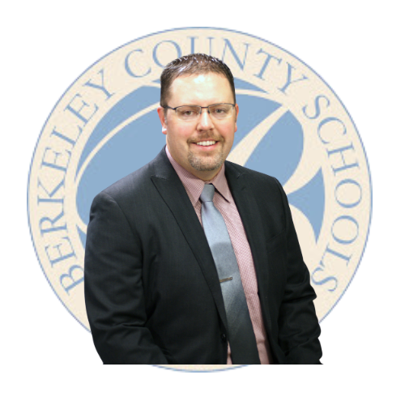  AI in the Language Classroom: Unlocking New Possibilities | Wednesday, April 16 ▪ 4-5 PM    Unleashing the Power of AI Tools in Language Education
Presenter: Derek Oldfield…  …is an instructional technology coordinator for Berkeley County Schools who supports and inspires teaching and learning primarily at the middle and high school levels. He has been a keynote speaker at several events across the state of West Virginia. Derek spends most of his days with teachers across BCS, providing trainings, co-planning rich experiences, or even co-teaching in the classroom. He recently spearheaded a group of educators from across West Virginia that designed and created training materials to help districts navigate this new disruption to education - artificial intelligence. | Presenter: Joe Dale…  …is an independent languages consultant from the UK who works with a range of organizations such as Network for Languages, ALL, The British Council, the BBC, Skype, Microsoft and The Guardian. His many accomplishments include:  - former SSAT Languages Lead Practitioner,  - recognized Expert on Technology and Language Learning  - regular International Conference Speaker & Trainer  - Adviser to government groups & companies  - Creator of ICT activities
For session descriptions, see next page.
Sessions will be recorded for those who cannot attend on a particular date or time.
REGISTER TODAY | CE Credit is available from Concord University.  CONCORD Registration COURSE DESCRIPTION

Session with Derek Oldfield on March 12 - Description
Artificial Intelligence is rapidly transforming education, offering foreign language teachers powerful tools to enhance instruction, foster engagement, and support student learning. In this interactive session, we’ll explore how AI can assist with lesson planning, content creation, and personalized learning. From AI-powered writing assistants to innovative experiences that harness AI, you'll discover practical ways to integrate AI into your teaching while maintaining academic integrity and fostering authentic language acquisition. No prior AI experience is necessary—just bring your curiosity and creativity!
Session with Joe Dale on April 16 – Description
Artificial Intelligence is transforming language education, offering innovative ways to enhance lesson planning, student engagement, and assessment. In this interactive session, we will explore practical AI tools that world language teachers can use to support all four language skills while maintaining academic integrity. By the end of the session, participants will have practical strategies and AI-powered tools to integrate AI into their language classrooms effectively, fostering engagement and enhancing learning outcomes.

Questions: Contact Nancy – wv.nsryan@gmail.com
Or Terri – terrimarlow8@gmail.com

